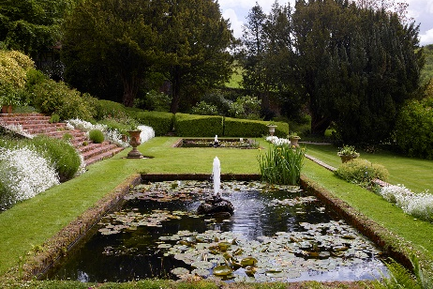
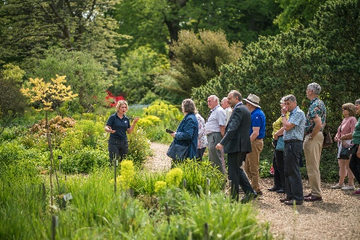
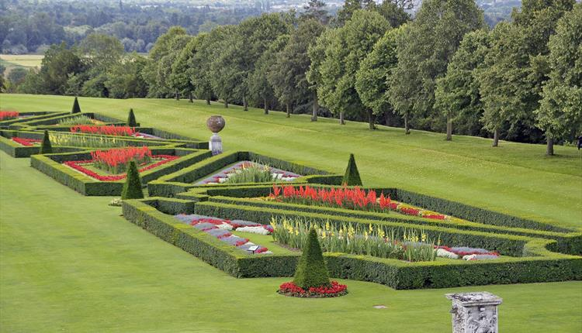
GARDEN VISITS ALONG THE RIVER THAMES

Where better to explore the diversity and history of English gardens than along the Royal River Thames, where history stretches back over 2,000 years.
READING
Forbury Gardens and Abbey Quarter Reading www.visitthames.co.uk/things-to-do/reading-abbey-quarter-p1569511
Forbury Gardens is a delightful Victorian town garden, created at the height of the urban parks movement. They are located between the town centre and the ruins of the 11th century abbey, not far from Reading Station. The Abbey Quarter covers the former precinct of one of Europe's largest royal monasteries and dates back over 900 years. There are remains of the south transept (the arms that project at right angles from the church, forming a cross shape), the treasury, the chapter house, the dormitory and the refectory. The Grade I listed Gateway overlooking the Forbury Gardens is a substantial part of what remains of Reading Abbey. The Abbey Gateway was once part of the Reading Girls School attended by Jane Austen and her sister Cassandra.
Museum of English Rural Life www.visitthames.co.uk/things-to-do/museum-of-english-rural-life-p57053
It houses the most comprehensive national collection of objects, books and archives relating to the history of food, farming and the countryside. The garden is a peaceful, green oasis in the middle of Reading with herbaceous borders of medicinal, culinary, and multi-purpose plants, a wildflower bank and woodland area .
Combine with… Thames Rivercruise www.thamesrivercruise.co.uk/group-boat-trips
Plan a day, afternoon or short cruise on the Thames for groups. Available for tour operators and associations, are a selection of exclusive hire boat trips from Caversham for groups of 20+.
HENLEY ON THAMES
Stonor Park www.stonor.com/plan-your-day/prices/
Guided tour of the House/Chapel/Gardens or book a Gardens Tour. Home to the Stonor family for over 850 years, Stonor Park is one of the oldest family homes still lived in today – but it’s no museum. The lush parkland of Stonor is set in a dramatic, sweeping valley deep within the heart of the Chiltern Hills. There are three gardens to explore; the ponds and fountains of the 17th Century Italianate Pleasure Garden, the old Kitchen Garden designed and nurtured by Lady Camoys and the Arboretum. The Old Kitchen Garden is planted with apple and plum trees which blossom sensationally in the spring. In the Arboretum the young nut trees and long hazelnut avenue were planted in wake of the great storm of 1991.
Greys Court www.nationaltrust.org.uk/visit/oxfordshire-buckinghamshire-berkshire/greys-court
Discover Greys Court, an intimate family home set in the rolling hills of the Chilterns. From a Tudor show house to 20th-century family home. There have been gardens at Greys Court for hundreds of years, since at least the 13th century. There is little evidence about what the garden looked like before the Brunners arrived in 1937. Features in the garden include Moon Bridge, The Maze and the Octagonal fountain.
Combine with… A Vintage Afternoon Tea Cruise with Hobbs of Henley www.hobbsofhenley.com/whats-on-when
A quintessentially English afternoon tea and 3 hour cruise on from Henley on the spectacular New Orleans.
WINDSOR
The Savill Garden www.windsorgreatpark.co.uk/explore/the-gardens/the-savill-garden
First created by Sir Eric Savill, as his woodland garden in the 1930s, The Savill Garden, in Windsor Great Park, is known as Britain's finest ornamental garden, a garden for all seasons and a place of beauty and colour that's loved by horticulturalists and enthusiasts alike. With 35 acres of interconnecting gardens and exotic woodland, each garden has its own unique attraction, featuring a distinctive group of plants that introduce a fresh burst of vibrant colour throughout the seasons. It features plants from all over the world.
Cliveden National Trust www.visitthames.co.uk/things-to-do/cliveden-p49801
The magnificent gardens and breath-taking views over the River Thames have been admired for centuries. From late March to late April the garden will be a haze of blue whilst the sweet scent of 20,000 hyacinth bulbs gently wafts through the air. There are walking routes suitable for a variety of abilities. Cliveden offers guided visits of Cliveden House on a first-come, first-served basis, as well as Garden tours, subject to confirmation with the gardens team.
RICHMOND UPON THAMES
Hampton Court Palace www.visitthames.co.uk/things-to-do/hampton-court-palace-p1142791
Relax in over 60 acres of the beautiful Hampton Court Palace gardens that run down to the River Thames, featuring sparkling fountains, glorious displays of over 200,000 flowering bulbs and 750 acres of tranquil royal parkland. The Privy Garden is the re-creation of William III’s Privy Garden, based on a design of 1702, the 20th Century Garden is contemporary style planting with trees and shrubs in an informal. Hampton Court Palace Maze - begun in 1690 as a form of courtly entertainment for William III, today the Maze covers one third of an acre and consists of half a mile of winding paths surrounded by towering 7ft-high yew tree walls.
Kew Gardens www.kew.org
Discover the world of science behind the botanical collections, with over 50,000 living plants to be found across this UNESCO World Heritage site. From the vast Arboretum to an Alpine rock garden, there's something to see in every corner.
Combine with a cruise with Thames River Boats www.thamesriverboats.co.uk/info/index.asp?page=groups-travel-trade-121. Cruises from Kew Pier, Richmond Landing Stage and Hampton Court Landing Stage with a fleet of traditional River Thames passenger boats. A range of cruises are available for groups ranging from 30-minutes to 3-hours & 30-minutes.
TAKE A LOOK AT VISIT THAMES WEBSITE
www.visitthames.co.uk/things-to-do/attractions/gardens-along-the-river-thames

